Operational Research
  - Flow Shop Scheduling Tutorial – Answers

Johnson’s Rule
  - List the jobs.
  - Select the job with the shortest activity time, break ties arbitrarily.
    - If shortest is for first stage, schedule as early as possible.
    - Else if shortest is for second stage, schedule as late as possible.
  - Remove the job from list.
  - Repeat 2 and 3 until no jobs are left to schedule.

Example
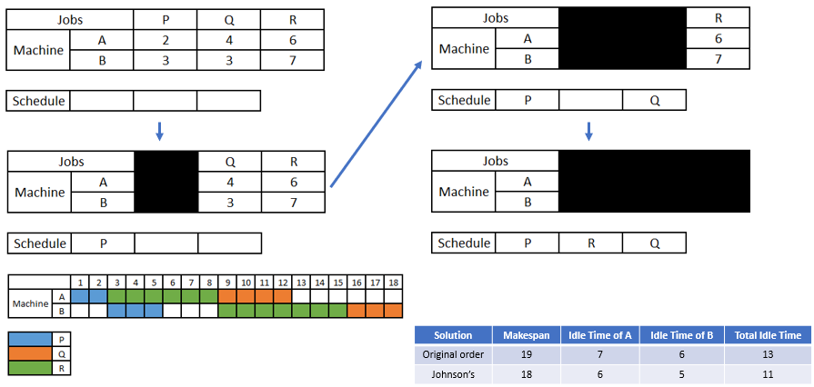

Determining Makespan via Network
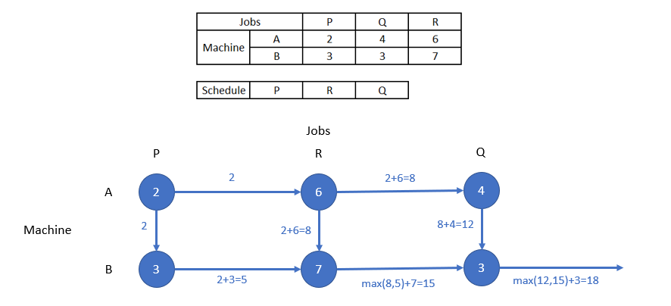

Exercises

- Use Johnson’s Rule to determine the optimal production schedule for the following problem
  - Draw a Gantt Chart displaying the jobs on the given machines.
  - Calculate the minimum Makespan
  - Calculate the idle times for the machines and therefore the total idle time

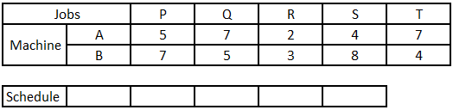

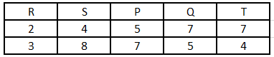

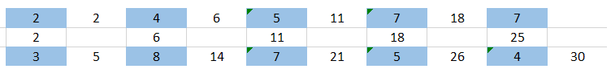

Makespan – 30

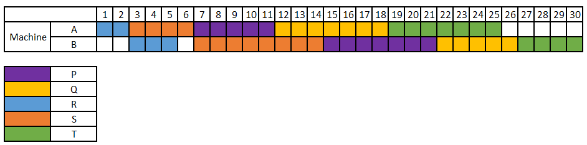

Idle time on A – 5
Idle time on B - 3
Total - 8

- Use Johnson’s Rule to determine the optimal production schedule for the following problem
  - Calculate the minimum Makespan via a network representation

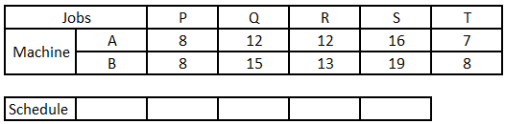

Depending on how you choose to schedule P, either at the beginning or the end… Both orders give the minimum makespan, 74.

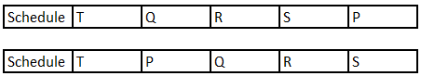

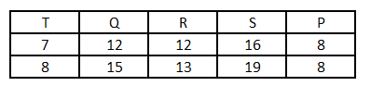

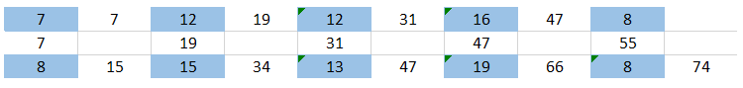

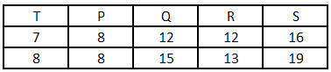

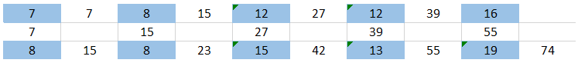

- By applying Johnson’s Rule determine a good production schedule for the following problem and compare this to the original order solution. To do the comparison you will need to compute the Makespan of both the original order and your solution, this would make a good exercise to try in Excel…

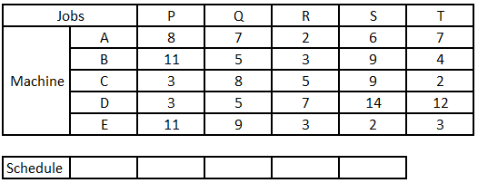

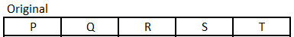

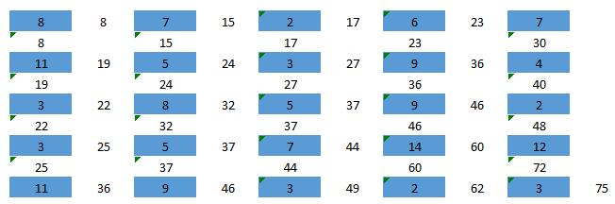

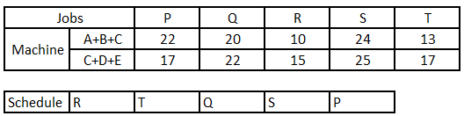

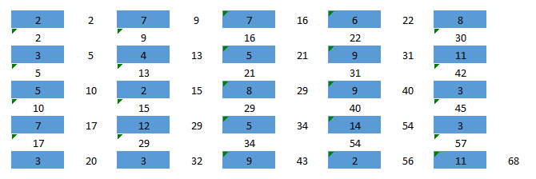

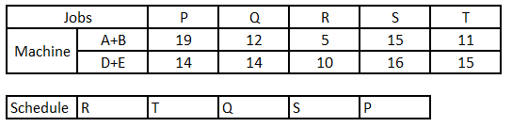

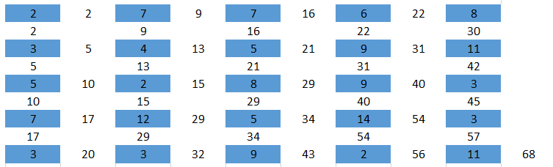

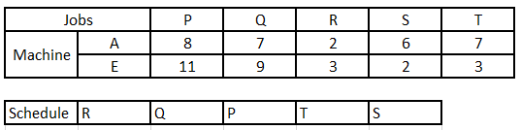

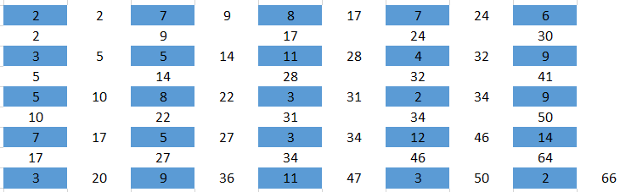

Best heuristic order: RQPTS, makespan 66, given by Johnson’s Rule with the Campbell, Dudek and Smith heuristic.
Machines A and E considered. Aggregating A+B and D+E, Johnson’s Rule gives RTQSP (makespan 68). A+B+C and C+D+E also give RTQSP (68).
These are heuristics: checking all 5! = 120 orders shows that the optimal makespan is 64, with RPTQS, the only optimal order (see Q4). Gantt chart for RQPTS:

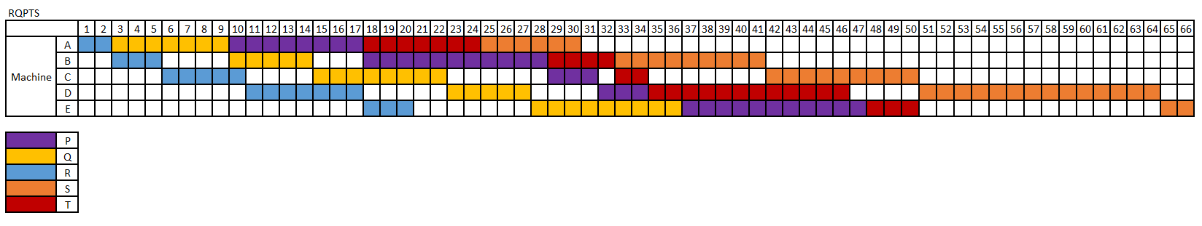
- Can you write a Linear Program or Mixed-integer Linear Program to solve this?
Yes. The notebook Flow Shop Q4 MILP answers.ipynb (in 4 Tutorial Answers) writes the problem as a mixed-integer linear program, with one binary variable for each pair of jobs that decides which job goes first on every machine. It finds the optimal makespans 30 (Q1), 74 (Q2) and 64 (Q3).

